Part 1: For each statement or question, choose the word or expression that, of those given, best completes the statement or answers the question
- Which function is even? SCRAP
- $f\left(x\right)=\sin{x}$
- $f\left(x\right)=x^{2}-4$
- $f\left(x\right)=\left|x-2\right|+5$
- $f\left(x\right)=x^{4}+3x^{3}+4$

- If $f(x)$is an even function, which function must also
be even?
- $f\left(x-2\right)$
- $f\left(x\right)+3$
- $f\left(x+1\right)$
- $f\left(x+1\right)+3$

- Which equation represents an odd function?
- $y=\sin{x}$
- $y=\cos{x}$
- $y={\left(x+1\right)}^{3}$
- $y=e^{5x}$

- The graph of the function $p(x)$ is sketched below.
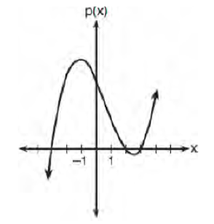
Which equation could represent $p(x)$?
- $p\left(x\right)=\left(x^{2}-9\right)\left(x-2\right)$
- $p\left(x\right)=x^{3}-2x^{2}+9x+18$
- $p\left(x\right)=\left(x^{2}+9\right)\left(x-2\right)$
- $p\left(x\right)=x^{3}+2x^{2}-9x-18$
- Which description could represent the graph of
$f\left(x\right)={4x}^{2}\left(x+a\right)-x-a$, if $a$ is an integer?
- As $x→-∞, f\left(x\right)→∞, as x→∞, f\left(x\right)→∞,$
and the graph has 3 $x$-intercepts.
- As $x→-∞, f\left(x\right)→-∞, as x→∞, f\left(x\right)→∞,$
and the graph has 3 $x$-intercepts.
- As $x→-∞, f\left(x\right)→∞, as x→∞, f\left(x\right)→-∞,$
and the graph has 4 $x$-intercepts.
- As $x→-∞, f\left(x\right)→-∞, as x→∞, f\left(x\right)→∞,$
and the graph has 4 $x$-intercepts.

- The roots of the equation $x^{2}+2x+5=0$ are
- $-3$ and $1$
- $-1$, only
- $-1+2i$ and $-1-2i$
- $-1+4i$ and $-1-4i$

- A sketch of $r(x)$ is shown below.
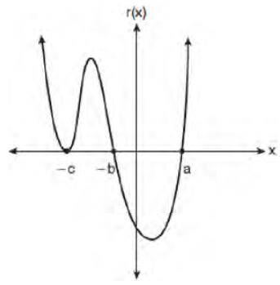
An equation of for $r(x)$ could be
- $r\left(x\right)=\left(x-a\right)\left(x+b\right)\left(x+c\right)$
- $r\left(x\right)=\left(x+a\right)\left(x-b\right){\left(x-c\right)}^{2}$
- $r\left(x\right)=\left(x+a\right)\left(x-b\right)\left(x-c\right)$
- $r\left(x\right)=\left(x-a\right)\left(x+b\right){\left(x+c\right)}^{2}$

- Which equation represents the equation of the parabola
with focus $(-3, 3)$ and directrix $y = 7$?
- $y=\frac{1}{8}{\left(x+3\right)}^{2}-5$
- $y=\frac{1}{8}{\left(x-3\right)}^{2}+5$
- $y=-\frac{1}{8}{\left(x+3\right)}^{2}+5$
- $y=-\frac{1}{8}{\left(x-3\right)}^{2}+5$

- The solution to the equation $-\frac{1}{2}x^{2}=-6x+20$ are
- $-6±2i$
- $-6±2\sqrt{19}$
- $6±2i$
- $6±2\sqrt{19}$

- If $A=-3+5i$, $B=4-2i$, and $C=1+6i$, where $i$ is
the imaginary unit, then $A-BC$ equals
- $5-17i$
- $5+27i$
- $-19-17i$
- $-19+27i$

- The graph of $p(x)$ is shown below.
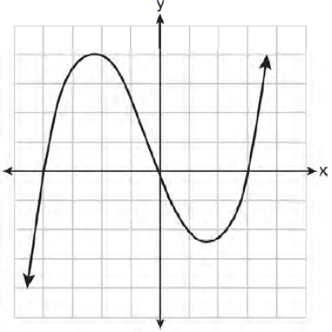
What is the remainder when $p(x)$ is divided by
$x+4$?
- $x-4$
- $-4$
- $0$
- $4$

- The solutions to the equation ${5x}^{2}-2x+13=9$ are
- $\frac{1}{5}±\frac{\sqrt{21}}{5}$
- $\frac{1}{5}±\frac{\sqrt{19}}{5}i$
- $\frac{1}{5}±\frac{\sqrt{66}}{5}i$
- $\frac{1}{5}±\frac{\sqrt{66}}{5}$

- Factored completely, $m^{5}+m^{3}-6m$ is equivalent to
- $\left(m+3\right)\left(m-2\right)$
- $\left(m^{2}+3m\right)\left(m^{2}-2\right)$
- $m\left(m^{4}+m^{2}-6\right)$
- $m\left(m^{2}+3\right)\left(m^{2}-2\right)$

- If $\left(a^{3}+27\right)=\left(a+3\right)\left(a^{2}+ma+9\right)$, then $m$ equals
- $-9$
- $-3$
- $3$
- $6$

- What is the solution set of the equation
$\frac{2}{3x+1}=\frac{1}{x}-\frac{6x}{3x+1}$?
- $\left\{-\frac{1}{3},\frac{1}{2}\right\}$
- $\left\{-\frac{1}{3}\right\}$
- $\left\{\frac{1}{2}\right\}$
- $\left\{\frac{1}{3},2\right\}$

- Given $c\left(m\right)=m^{3}-2m^{2}+4m-8$, the solution of
$c\left(m\right)=0$ is
- $±2$
- $2$, only
- $2i, 2$
- $±2i, 2$

Part 2: Show all necessary work to receive credit.
- The distance needed to stop a car after applying the brakes varies directly with the square of the car’s speed. The table below shows stopping distances for various speeds.
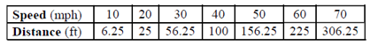
Determine the average rate of change in braking distance, in ft/mph, between one car traveling at 50 mph and one traveling at 70 mph. Explain what this rate of change means as it relates to braking distance.

- Express ${\left(1-i\right)}^{3}$ in $a+bi$ form.

- Algebraically solve for $x$: $\frac{7}{2x}-\frac{2}{x+1}=\frac{1}{4}$

- Algebraically determine the values of $x$ that satisfy the system of equations below:
$$y=-2x+1$$
$$y={-2x}^{2}+3x+1$$

- Solve the following system of equations algebraically.
$$x^{2}+y^{2}=400$$
$$y=x-28$$

- Determine the quotient and remainder when $\left({6a}^{3}+{11a}^{2}-4a-9\right)$ is divided by $\left(3a-2\right)$. Express your answer in the form $q\left(a\right)+\frac{r(a)}{d(a)}$.

- Given $a\left(x\right)=x^{4}+{2x}^{3}+4x-10$ and $b\left(x\right)=x+2$, determine $\frac{a(x)}{b(x)}$ in the form $q\left(x\right)+\frac{r(x)}{b(x)}$. Is $b(x)$ a factor of $a(x)$? Explain.

- When the function $p(x)$ is divided by $x-1$ the quotient is $x^{2}+7+\frac{5}{x-1}$. State $p(x)$ in standard form.

- Solve the following system of equations algebraically for all values of $x$, $y,$ and $z$:
$$2x+3y-4z=-1$$
$$x-2y+5z=3$$
$$-4x+y+z=16$$

